CARGO DANGEROUS GOODS OCCURRENCE REPORT - PART 1
EU Regulations require occurrences to be reported to the HCAA within 72 hours of the occurrence becoming known to the reporter (see Note 6)

Please ensure that both parts 1 and 2 of this form are completed
1. Aircraft operator: |  | 2. Date of occurrence: |  | 3. Local time of occurrence:
4. Flight date: | 5. Flight number: |  | 6. Aircraft type: |  | 7. Aircraft registration:
8. Location of occurrence: | 9. Origin of goods: |  | 10. Departure airport: |  | 11. Destination airport:
12. AWB number: | 13. House AWB: |  | 14 Consignment number: |  | 15. Total No. of pieces:
16. Shipper name and address: |  |  | 17. Consignee name and address:
18. Names and addresses of all other companies involved (courier company/freight forwarder):
19. Description of occurrence: (if necessary, continue on additional page)
20. Consignment is being held:  Yes/No (See Note 9) |  | 21. Location consignment is held: |  | 22. Photographs are available:  Yes/No
23. Name/title of person reporting: |  | 24. Tel: |  | 25. Reporter's reference/ASR number:
26. Company and address: |  | 27. Fax: |  | 28. Date of report:
 |  | 29. E-mail: |  | 30. Signature:

PART 2
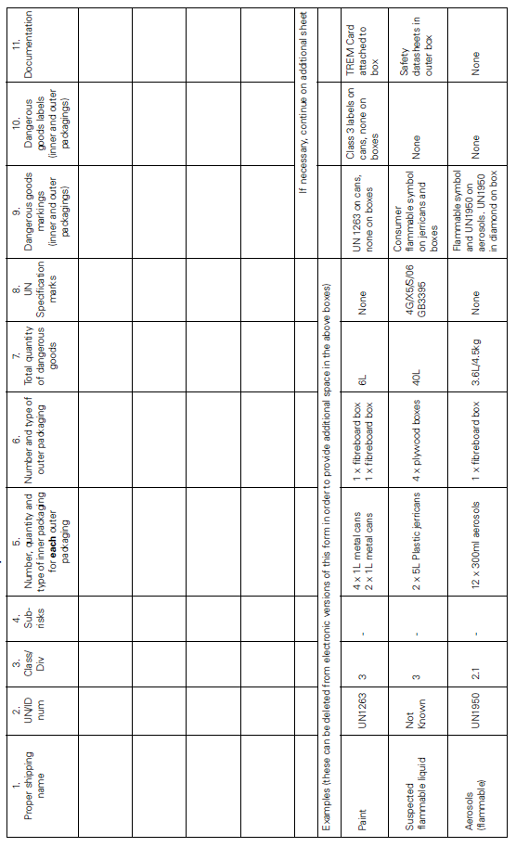

CARGO DANGEROUS GOODS OCCURRENCE REPORT - NOTES
- It is important that this form is completed in as much detail as possible; this will help to avoid delays in processing the report and unnecessary additional work by both the reporter and the HCAA.
- Any type of dangerous goods occurrence must be reported, irrespective of whether the dangerous goods are contained in cargo, mail or baggage.
- A dangerous goods accident is an occurrence associated with and related to the transport of dangerous goods which results in fatal or serious injury to a person or major property damage. For this purpose serious injury is an injury which is sustained by a person in an accident and which: (a) requires hospitalization for more than 48 hours, commencing within 7 days from the date the injury was received; or (b) results in a fracture of any bones (except simple fractures of fingers, toes or nose); or (c) involves lacerations which cause severe hemorrhage, nerve, muscle or tendon damage; or (d) involves injury to any internal organ; or (e) involves second or third degree burns, or any burns affecting more than 5% of the body surface; or (f) involves verified exposure to infectious substances or injurious radiation. A dangerous goods accident may also be an aircraft accident; in which case the normal procedure for reporting of air accidents must be followed.
- A dangerous goods incident is an occurrence, other than a dangerous goods accident, associated with and related to the transport of dangerous goods, not necessarily occurring on board an aircraft, which results in injury to a person, property damage, fire, breakage, spillage, leakage of fluid or radiation or other evidence that the integrity of the packaging has not been maintained. Any occurrence relating to the transport of dangerous goods which seriously jeopardizes the aircraft or its occupants is also deemed to constitute a dangerous goods incident.
- This form should also be used to report any occasion when undeclared or misdeclared dangerous goods are discovered in cargo, mail or unaccompanied baggage. A separate form is available for incidents related to passengers/crew.
- An initial report, which may be made by any means, must be dispatched within 72 hours of the occurrence, to the Authority of the State (a) of the operator; and (b) in which the incident occurred, unless exceptional circumstances prevent this. This occurrence report form, duly completed, must be sent as soon as possible, even if all the information is not available.
- Copies of all relevant documents and any photographs should be attached to or sent with this report.
- Completed reports must be sent to the HCAA, Dangerous Goods Office, e-mail address: dgo@hcaa.gov.gr.
- Providing it is safe to do so, all dangerous goods, packaging, documents etc. relating to the occurrence must be retained in a suitable location until after the initial report has been sent to the Dangerous Goods Office, CAA and they have indicated whether or not these should continue to be retained.
- Below are further explanations for some of the boxes on Part 1 of this form:

Box Explanation/details
1 Operator of the aircraft that the goods travelled on or on which they would have travelled if not intercepted.
4 – 7 To be completed if goods were carried or if goods had been allocated to a particular flight.
- Location on aircraft or name of airport/town if found before or after flight.
- Airport or country.
12 - 14 All applicable references for the consignment should be shown.
- The total number of pieces in the consignment, including any not containing dangerous goods.
16-17 The shipper and consignee, as shown on either the accompanying documentation or on the packages themselves. These boxes should not be used to show the company delivering the consignment to the airport (see box 18).
19 How the incident occurred, how it was found (e.g. by x-ray, freight checks, upon unloading etc.), the reason for the occurrence and any action taken as a result of occurrence.
22 Digital photographs of the consignment are extremely useful. If photographs cannot be taken (and only if safe to do so) photocopies of markings/labels on packaging can also be of use.
11 At the bottom of Part 2 there are examples of how to complete that part. Below are further explanations for some of the boxes:

Box Explanation/details
5 - 6 Give as much detail as possible in order to identify exactly the number and type of inner and outer packaging and the quantities of dangerous goods for each inner packaging.
9 - 10 It is important to record any dangerous goods markings and labelling visible on the inner and/or outer packaging since this may determine the action taken by the HCAA. Note that the following type of marking (UN number inside a diamond) is sometimes used for dangerous goods being transported by road/sea and should be recorded:

